Practical - 8
Practical Title: MySQL Schema Design, ER Model, PDO Connectivity, and Prepared Statements.
Design the database for StudentHub with students, events and registrations. Create PHP database connection using MYSQL statements.

Theory
- Is the schema normalized properly?
Yes, the database is normalized by storing students, events, and registrations in separate tables to reduce data redundancy and maintain data consistency.
- Are primary keys and foreign keys correctly defined?
Yes, primary keys uniquely identify each record, while foreign keys in the registrations table link students and events and maintain referential integrity..
- Is database connection handled securely?
Yes, PDO is used with exception handling, UTF-8 encoding, and prepared statements to handle database errors and help prevent SQL injection.

Implementation/ Output/Result
Tags:
- Created a MySQL database named studenthub with students and registrations tables.
- Defined primary keys and foreign keys to establish relationships between tables.
- Established a database connection using PHP PDO.
- Used prepared statements to securely insert and retrieve student details.

Output Screenshots:
Database structure:
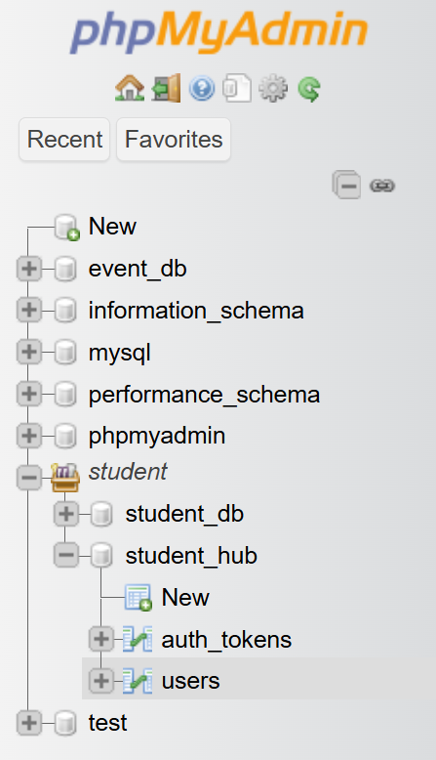

New Student Registration:
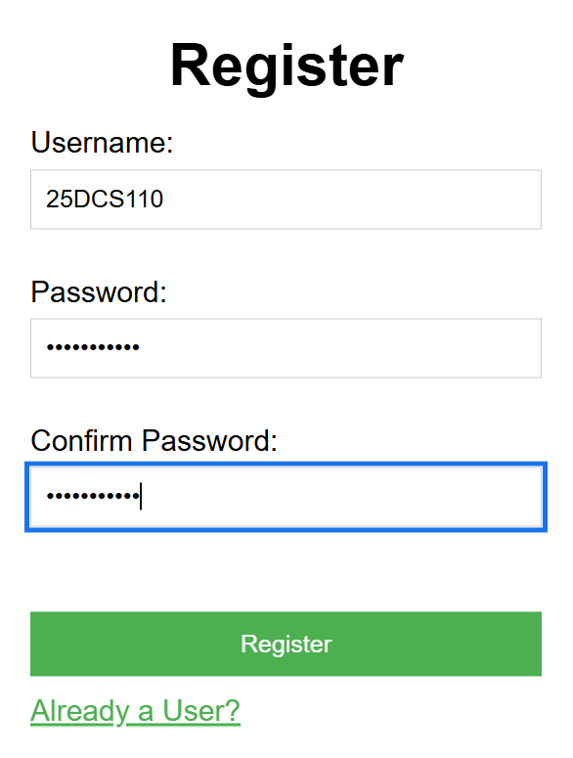

After Clicking Register Button:
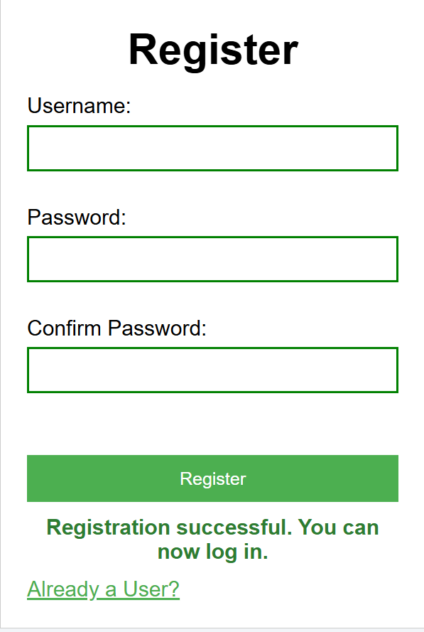

Registration of Existing Student:
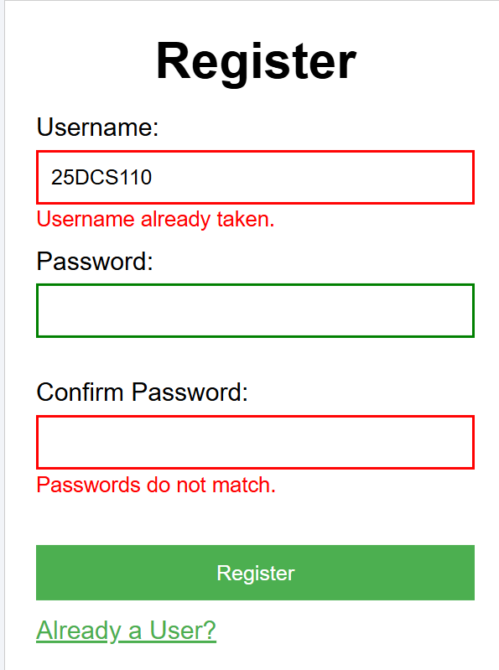

Successful Login for Register Student:
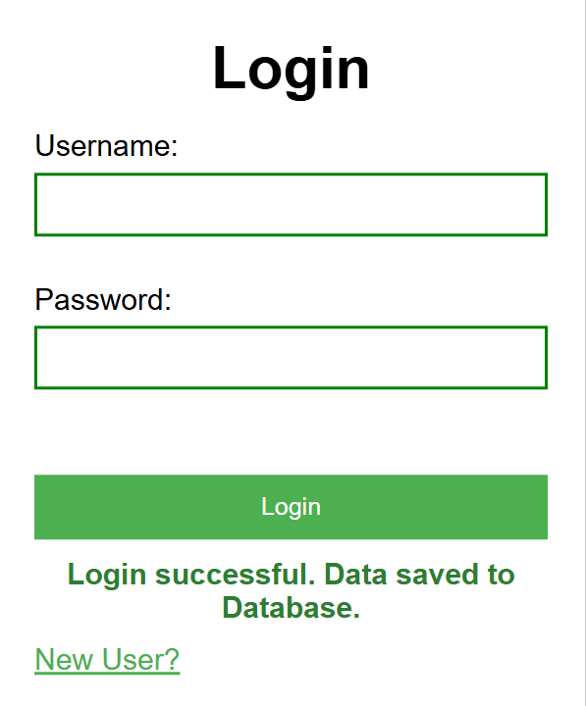

GitHub Repository Link:
https://github.com/HimeshMale/Student-Hub-Portal.git

Challenges Faced:

It was not too difficult but I faced challenge in creating a php file and retrive data from student database table into events table and in PHP page.

Learning Outcomes:
Learned to design a normalized MySQL database, establish a secure PDO connection, and use prepared statements to insert and retrieve data securely.

Faculty Remarks:

